
Upperby Primary School YEAR 5 CURRICULUM MAP 2025-2026

SUBJECT | Autumn 1 Autumn 2 |  | Spring 1 Spring 2 |  |  |  | Summer 1 Summer 2
English | One small step  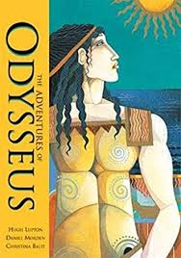  Adventures of Odysseus | Mars transmission  Poetry- Jabberwocky   | The fantastic flying books of Mr Morris Lesmore  Should work houses be closed?  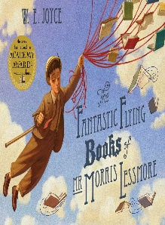 |  | David Attenborough biography  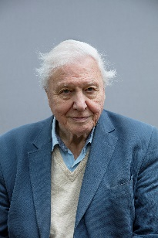  Poetry- Cloud Busting |  | Cosmic  Poetry – The Butterfly Lion   | Nowhere emporium  Discussion text,  ‘Where would be best to live?’  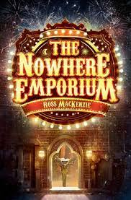
English | - Fiction  - Myth  - Prologue of a myth | - Non-fiction journal  - Poetry unit | - Fiction  - Discussion Text – Should the workhouse be closed?  - Persuasive text – Advert for a Victorian invention |  | - Biography  - Poetry |  | - Narrative  - Poetry | - Narrative  - Non-Fiction
Maths | Number – Place Value  Number – Addition and Subtraction  Number- Multiplication and division A  Number- Fractions A |  | Number – Multiplication and division B  Number – Fractions A  Number – Decimals and percentages  Measurement- Perimeter & Area  Statistics |  |  |  | Geometry- Shape  Geometry – Position and direction  Number- decimals  Number- Negative numbers  Measurement – Converting Units  Measurement - Volume
Science | Earth & Space Describe the movement of the Earth and other planets relative to the sun in the solar system.  Describe the movement of the moon relative to the Earth.  Describe the sun, Earth and moon as approximately spherical bodies. | Forces  Explain that unsupported objects fall towards the Earth because of the force of gravity acting between the Earth and the falling object.  Identify the effects of air resistance, water resistance and friction that act between moving surfaces. | Properties of materials  Compare and group together everyday materials on the basis of their properties, including their hardness, solubility, transparency, conductivity (electrical and thermal), and response to magnets. |  | Changes of materials  Use knowledge of solids, liquids and gases to decide how mixtures might be separated, including through filtering, sieving and evaporating. |  | Living things Describe the differences in the life cycles of a mammal, an amphibian, an insect and a bird.  Describe the life process of reproduction in some plants and animals.  First week A2 | Humans including animals  Describe the changes as humans develop to old age.
History | Ancient Greece  The story of the Trojan Horse: historical fact, legend or classical myth?  Which was the greatest city state, Athens or Sparta? |  | The Victorians  Why did Britain rule the largest empire in the world? |  |  |  | Medical Breakthroughs  How have medical breakthroughs affected the lives of British people?
Geography |  | Mountains  Why are mountains important us? |  |  | National Parks and Rivers  Who are Britain’s National Parks for? |  |  | Local Area Study  Is area X a better area to live than area Y and if so, how?
Art | Drawing Depth |  | Portraits |  |  |  | Architecture
DT |  | Structures  Picture frame |  |  | Mechanisms  Moving Monster |  | Food Technology  Pizza Wraps | Textiles  Fabric walker’s pouch
Computing | How to use the Internet Safely |  | Computing systems and networks |  |  |  | Microbits
PSHE | Core skills | Taking part  CHIPS lesson 1 | Being different  CHIPS lesson 2 |  | Being a risk taker  CHIPS lesson 3 |  | Healthy lifestyles  awareness | Living in the wider world, Sex and relationships education.
PE | Dodgeball - Gym  Tag rugby | Pilates  Cricket | Dance  Netball |  | Gym  Rounders |  | Swimming  Rounders | Orienteering/ Athletics  Swimming
RE | Sikhism - How far would a Sikh go for his/her religion? | Christianity – Is the Christmas story true? | Sikhism – Are Sikh stories important today? |  | Christianity – How significant is it for Christians to believe that God intended Jesus to die? |  | Sikhism –  What is the best way for a Sikh to show commitment to God? | Christianity – What is the best way for Christians to show commitment to God?
Music | Rhythm & Pulse  Pitch |  |  | Musical tuition |  | Rhythm & Pulse  Pitch
French | French monster pets | Space exploration | Shopping in France |  | French speaking world |  | Verbs in a French week | My French family
Possible Enrichment  Opportunities | Whinlatter – mountains  Christian visit for unit |  | Beamish – Victorian life  Coniston residential |  |  |  | Field trip - Local area study of Carlisle

