YEAR 3/4 CURRICULUM MAP 2025-2026

SUBJECT | Autumn 1 Autumn 2 |  | Spring 1 Spring 2 |  | Summer 1 Summer 2
English | Jane Considine - The True Story of the Three Little Pigs  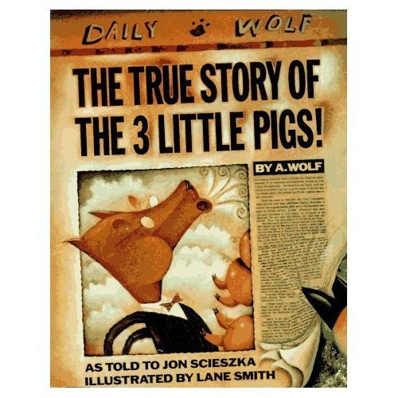 | Jane Considine - Christmas Dessert Social Media Post  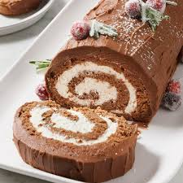 | Jane Considine - The Boy, The Mole, The Fox and the Horse  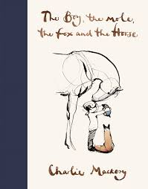 | Jane Considine -  The Gardener  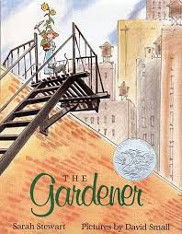 | Jane Considine -  Inside the Pyramid  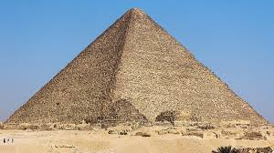 | Jane Considine -  Instructions for a Robot Dog  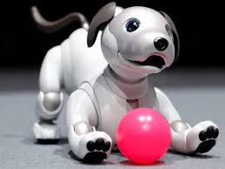
English | Writing Outcomes:  Narrative - traditional tale | Writing Outcomes:  Social media post, persuasive writing. | Writing Outcomes:  Narrative | Writing Outcomes:  Letter | Writing Outcomes:  Narrative - adventure | Writing Outcomes:  Explanation text
Maths | Number: Place Value – 4 weeks Addition and Subtraction - 4 weeks Multiplication and Division - 3 weeks  Area - 1 week |  | Number: – Multiplication and Division - 3 weeks  Measurement: Length and Perimeter-2 weeks  Number: Fractions - 3 weeks  Measurement: Mass and capacity-2 weeks  Number: Fractions - 2 weeks |  | Measurement: Time – 2 weeks  Number: Decimals - 3 weeks  Measurement: Money- 2 weeks  Geometry: Properties of shape – 2 weeks  Geometry: Position and Direction - 1 week  Statistics 2 weeks
Science | Electricity  Identify common appliances that run on electricity Construct a simple series electrical circuit, identifying and naming its basic parts, including cells, wires, bulbs, switches and buzzers  Identify whether or not a lamp will light in a simple series circuit, based on whether or not the lamp is part of a complete loop with a battery Recognise that a switch opens and closes a circuit and associate this with whether or not a lamp lights in a simple series circuit  Recognise some common conductors and insulators, and associate metals with being good conductors. | Sound  Identify how sounds are made, associating some of them with something vibrating Recognise that vibrations from sounds travel through a medium to the ear  Find patterns between the pitch of a sound and features of the object that produced it  Find patterns between the volume of a sound and the strength of the vibrations that produced it Recognise that sounds get fainter as the distance from the sound source increases | States of matter  Compare and group materials together, according to whether they are solids, liquids or gases  Observe that some materials change state when they are heated or cooled, and measure or research the temperature at which this happens in degrees Celsius (°C) Identify the part played by evaporation and condensation in the water cycle and associate the rate of evaporation with temperature | States of matter  Compare and group materials together, according to whether they are solids, liquids or gases  Observe that some materials change state when they are heated or cooled, and measure or research the temperature at which this happens in degrees Celsius (°C) Identify the part played by evaporation and condensation in the water cycle and associate the rate of evaporation with temperature. | Animals including humans  Describe the simple functions of the basic parts of the digestive system in humans Identify the different types of teeth in humans and their simple functions  Construct and interpret a variety of food chains, identifying producers, predators and prey. | Living things and their habitats  Recognise that living things can be grouped in a variety of ways Explore and use classification keys to help group, identify and name a variety of living things in their local and wider environment  Recognise that environments can change and that this can sometimes pose dangers to living things
History | Anglo Saxons  Who were the Anglo-Saxons and how do we know what was important to them?  Children will understand Britain’s settlement by Anglo-Saxons and Scots. |  | Vikings  What did the Vikings want and how did Alfred help to stop them getting it?  Children will understand the Viking and Anglo-Saxon struggle for the Kingdom of England to the time of Edward the Confessor. |  | Egyptians  What happened to the  boy behind the golden  mask?  Children will understand how archaeologists used artefacts and sources to find out about the life of Tutankhamun
Geography |  | South America - The Amazon  Why is the Amazon Basin important to us?  Understand geographical similarities and differences through the study of the human and physical geography of a region of the UK and a region within South America. Describe and understand key aspects of: - physical geography, including: climate zones, biomes and vegetation belts, rivers and the water cycle- human geography, including: types of settlement and land use, economic activity including trade links, and the distribution of natural resources. . |  | Sustainability  How can we live more sustainably?  Understand what sustainability is, how we can be sustainable and create action plans in regard to sustainability. Identify energy sources and how how they are used in UK. |  | North America  What is the difference between a continent, country and state?  Locate the world’s countries focusing on North America. Describe and understand the climate and geography of the country. Describe trade, energy, natural resources in the country.
Art | Drawing-Exploring texture, tone and proportion-3D drawings and shadows |  | Painting - Light and Dark  Explore difference between light and dark, tints, shades. Use shadow to show three dimensions. |  | Ancient Egyptian Scrolls  Exploring and creating ancient Egyptian art. Design scrolls, make paper and create contemporary responses using zines.
DT |  | Textiles and Materials Make a Christmas stocking Identify the correct material, design, cut, sew, create and evaluate |  | Electrical Systems Create buzz game Simple circuits and switches Design, make and evaluate a buzz game | Food/Nutrition  Making fruity cereal bar (Sports week) | Structures  Create a castle  How to follow a plan, stiffen and strengthen materials
PSHE | Core Skills | Taking Part | Valuing Difference | Being a Risk Taker | Healthy Lifestyles | Economic Wellbeing
Computing |  | Google: Computing systems and networks 2: Emailing  Log in and out of emails, send and reply |  | Coding/Further coding with Scratch  Programming a game using variables, sensors and if statements, then debugging and evaluating |  | Google: Creating media: Website design  Creating content and design own website
PE | Gym | Core Strength Pilates | Dance | Gym | Dance | Swim
PE | Tri Golf | Hockey | Basketball | Basketball | Orienteering/  Athletics | Tennis
RE | Judaism  How special is the relationship Jews have with God? | Christianity  What is the most significant part of the nativity story for Christians? | Judaism  How important is it for Jewish people to do what God asks them to do?  Extra RE day Could the Buddha’s teachings make the world a better place? | Christianity  Is forgiveness always possible for Christians? | Judaism  Key Question What is the best way for a Jew to show commitment to God? | Christianity  Key Question Do people need to go to church to show they are Christian?
Music | Ed Singing  Rhythm & Pulse  Pitch | Christmas  Ed singing | Ukulele | Ukulele | Rhythm & Pulse Pitch | Instrumental
French | Greetings | Colour Shape, Size | Numbers and Age | French Classroom | Bon Appetit | Shopping
Possible Enrichment Opportunities |  | Sophie Martin drawing workshop in school |  | Vikings Tullie house | Church trip | Residential

