

Upperby Primary School
YEAR 6 - CURRICULUM MAP 2025 to 2026

SUBJECT | Autumn 1 Autumn 2 |  |  |  | Spring 1 Spring 2 |  |  | Summer 1 Summer 2
English Text | Rose Blanche  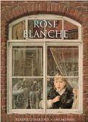 | WWII  Which children were affected the most?  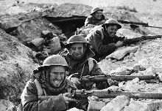 | Macbeth  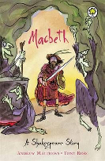 | The Day the Crayons Quit  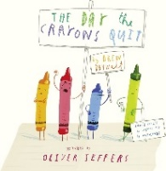 | Clockwork  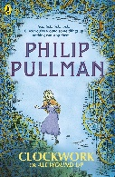 | Fairytale Retellings  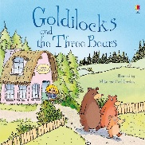 | Catch It – Literacy Shed Video  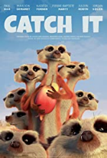 | Alma  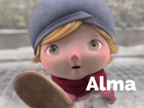 | Tickets please!  The Whale 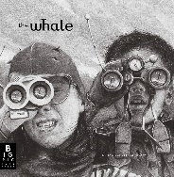 | Thinkers Rap  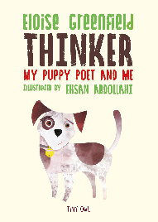
Writing Outcomes | Narrative | Debate | Newspaper Report  Narrative | Informal letter | Narrative  Instructions  Formal Letter  Debate | Postcard | Suspense Narrative | Narrative | Narrative | Poetry
Maths | Place value  Four operations  Fractions  Converting units |  |  |  | Ratio  Algebra  Decimals  Fractions, decimals and percentages  Area, perimeter and volume  Statistics |  |  | Shape  Position and direction  Maths base based projects Y6/7 transition.
Science | Electricity  Children develop learning  from year 4 to learn about electricity in more depth. They will develop understanding of circuits and their components; how professionals would use universal symbols to communicate these circuits; and how circuits can be manipulated. |  | Light  Children develop learning from year 3 to learn about more detailed components of light. They will explore how light travels; how shadows are formed and enquire about size; the effect of light being split (Refraction). |  | Animals including humans  Children develop learning from year 4 to learn about the circulatory system and how exercise, healthy lifestyle and drugs have an impact on the body. | Evolution and Inheritance  Children develop  learning from year 3 on rocks and begin to understand how and why animals (including themselves) have changed over the duration of millions of years. |  | Living Things and their Habitats  Children develop learning from year 4 of animal classification and begin to use and understand the universal Linnaean system. They will devise their own classification systems to understand its importance.

History | WWII  How were children affected by WWII?  - Timeline of WWII  - Mapping countries affected by WWII  - Evacuation non-chronological report  - Rationing (maths skills lesson)  - Propaganda  - Child’s perspective of Blitz writing  - Ranking effect on children |  | Mayans  Why did the ancient Maya change the way they lived?  - Who are the Maya and where did they live?  - The modern Maya civilisation  - Chichen Itza and Mayan archaeology  - Why do historians know so much about the Maya?  - Ancient Maya recreation  - Mayan downfall
Geography | Natural Disasters – Earthquakes  What impact can earthquakes have socially and economically?  - How do earthquakes occur?  - Mapping countries where earthquakes take place.  - Creating a seismometer  - Primary and secondary effects of an earthquake  - Can I compare and contrast the social and economic effects of two earthquakes?  - Case Studies of LEDC and MEDCs suffering from earthquakes. | The Mediterranean  Why is the Mediterranean an enviable area to live in?  - Identifying the boundaries of Europe and how it is described as a continent.  - Understand what life is like in a Mediterranean country.  - Research Italy as a country.  - Investigate a city within Italy and its geographical position.  - Can I consider how geographical position affects the people of Bologna?
Art | Drawing: Make my voice heard  This unit focuses on developing pupils' skills in using different art styles, exploring effects with tools, understanding and applying chiaroscuro, and creating symbolic and expressive drawings. It encourages children to form their own opinions about art, understand the impact of techniques, and convey messages through their artwork. | Painting & mixed media: artist study  This unit focuses on understanding narratives and descriptive language in art, exploring meanings behind paintings, and developing personal interpretations and abstract art pieces based on selected artists. Lessons explore creative expression, analysis, and evaluation skills in art. | Drawing: expressing ideas  Exploring how artists express ideas and how they use scale to do so.
DT | Textiles  Creating and designing a Christmas decoration. | Food  Eating healthily and becoming independent making dishes.  Healthy pasta and healthy muffins- Jamie Oliver study and recipe | Woodwork  Creating an animal home.
Computing | Bletchley Park and the history of computers | Introduction to Python (coding)  Online Safety | Big Data
PSHE | Core Skills |  | Taking Part  CHIPS - 1 | Being different  CHIPS - 2 | Being a risk taker  CHIPS – 3 |  | Healthy lifestyle (Drug, alcohol and tobacco awareness) | Economic well-being and financial capability  (& RSE)
PE | Indoor Athletics  Tennis  (Short Cross-Country Unit) |  | Dance  Tennis | Gymnastics  Netball | Dance  Orienteering/Athletics |  | Gymnastics  Cricket | Swimming  Rounders
RE | What is the best way for a Muslim to show commitment to God? |  | Do Christmas celebrations and traditions help Christians understand who Jesus was and why he was born? | Is anything ever eternal? | Is Christianity still a strong religion 2000 years after Jesus’ death? |  | Does belief in Akhirah (life after death) help Muslims lead better lives?
Music | Rhythm & Pulse  Pitch  (Composers: Stravinsky & Funk music) |  |  | Rhythm & Pulse  Pitch  (Composers: Haydn & Motown music) |  |  | Musical notation and composition – Ukuleles  Singing  (Composers: Wagner & Hip-Hop music)
French | French Sport and Olympics | French Football Champions |  | In my French House |  | Planning a French Holiday | Visiting a French Town | Recap of topics covered this year.
Possible Enrichment Opportunities | History Project Homework  Castle museum  Film Festival  Christmas Carol Concert |  |  | William Wordsworth Poetry Experience!  Spring 2 |  |  | Leavers’ Performance  Residential  Sports Week

