


RE Knowledge organiser
Religion /Worldview: Christianity | Enquiry Question: How significant is it for Christians to believe God intended Jesus to die? | Year: 5 Spring 2
In this enquiry, children look at the events of Holy Week (the week leading up to the death and resurrection of Jesus) to investigate the cause and effects of these events
Core Knowledge |  |  |  | 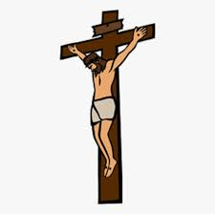
- Christians believe that Jesus is the son of God, who came to Earth in order to save humans from their sins. His death and resurrection opened up the way back to God and restored humanity’s relationship with him. This is the Christian concept of salvation
- The Bible cites many examples where Jesus says he knows he will be going to his death. It says he warned his disciples that “He will be handed over to the Gentiles. They will mock him, insult him, spit on him, flog him and kill him” (Luke 18:32). Later he told the Roman governor, Pilate, “For this reason I was born, and for this I came into the world” (John 18:37).

Vocabulary |  | History | Key Questions | Impact on believer/daily life
Pilate | The Roman governor of the region | Even from a human perspective, Jesus could have foreseen his likely fate. He faced constant opposition from the Pharisees and scribes, (Mark 3:22–27) who said he was a blasphemer (Mark 2:7), a false prophet (Mark 14:65), and a Sabbath breaker (Mark 2:23–28; 3:1–6; Luke 13:10–17; 14:1–6; John 5:1–18; 7:19–24). These crimes were punishable by death at the time.  Entering Jerusalem as he did and clearing the Temple would have been viewed as a dangerous provocation by the temple authorities. | - What sacrifices would I be prepared to make for something I felt was right or necessary?  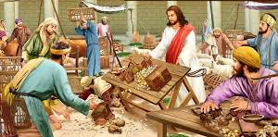  - Can I think of anything that I would wish to make a sacrifice for? | Christians believe that Jesus knew he had come into the world to die to bring about the salvation of humans. This can inspire them to believe Jesus was a very brave and special person, and also carry out sacrifices themselves (e.g. many Christians will abstain from things they enjoy during the 40 days before Holy Week known as Lent).
Incarnation: | God as man
Disciples: | Jesus’ special friends
Resurrection: | Coming back to life after being put to death
Pharisee: | a strictly orthodox Jew who adhered closely to the rules and scriptures
Crucifixion | being put to death by being nailed to a cross.
What I will know at the end?
Why Christians believe it was very important for Jesus to die to save people.
What my opinion is about Jesus being crucified.

