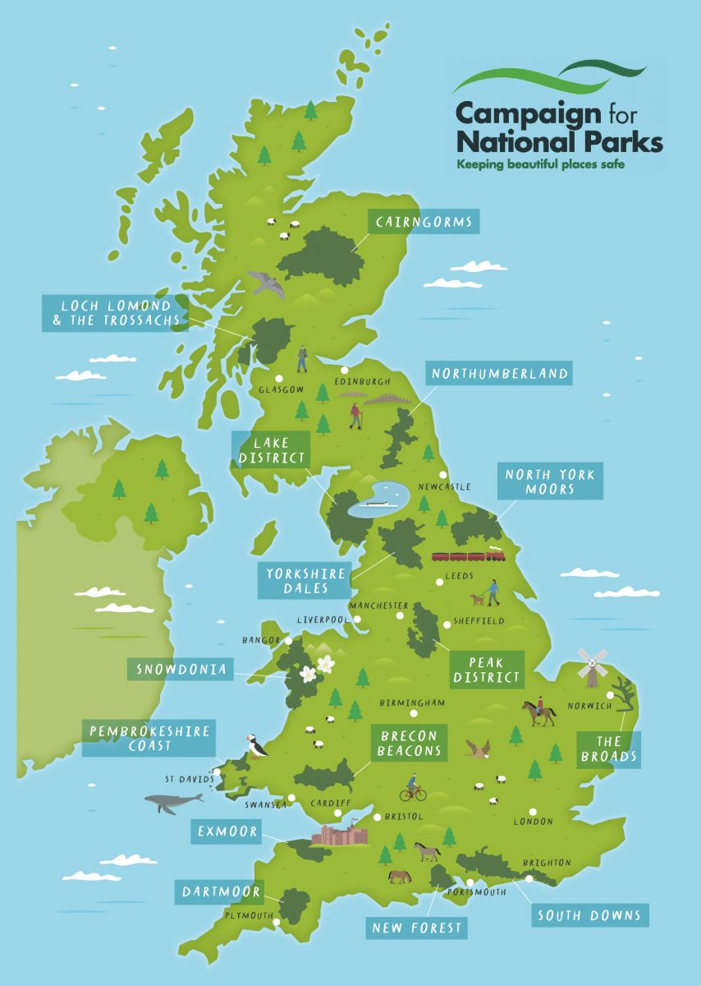
Vocabulary 10
The official supervision of rivers, forests and other natural resources to preserve and protect them
The way is something is spread over an area
Is the activity of making, providing purchasing, or selling goods and services
The surroundings or conditions in which a person, animal or plant lives
Valued objects and qualities such as historic buildings and cultural traditions that have been passed down in history
An area of countryside protected for the enjoyment of the general public or the preservation of wildlife
Existing in or derived from nature, not made or caused by mankind
Means having features which are typical of areas that are far from large towns and cities
Relating to an activity done for enjoyment when you are not working
Living in a city or town
Conservation Urban Recreational Natural
National Park Rural Environment Distribution Cultural Heritage Economic Activity
Britain’s Breathing Spaces: Who are National Parks for?

