A group of countries, people or land ruled by one single country referred to as the ‘mother’ country.
A country that is part of an empire.
The largest and richest part of Britain’s Empire.
A group of countries that were once part of Britain’s Empire.
The act of building an empire.
Wanting your country to be the best or to be free from someone’s empire.
A female figure used to symbolise the British Empire.
When the people of the country rule themselves.
The period of British rule in India after 1857. From the Hindi word for reign.
A leader of the Indian independence movement.
1)Mahatma Gandhi, 2)The Raj, 3)Independence, 4)Britannia, 5)Nationalism, 6)Imperialism, 7)Commonwealth, 8)Jewel in the crown, 9)Colony, 10)Empire
Why did Britain once rule the largest empire the world has ever seen?
By 1901, when Queen Victoria died, Britain ruled the largest empire the world had ever known. This included over 450 million people and covered one quarter of the surface of the world.
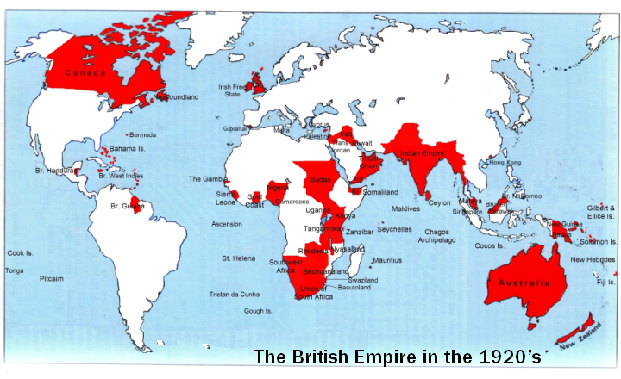

Key events
1837- Victoria ascends the throne
1838- Slavery abolished in the British Empire. Over 7000 slaves freed in the Caribbean alone.
1845- The potato famine started in Ireland, leading to over 1 million people emigrating
1854- The Crimean War starts against Russia- leading to the loss of 1.5 million lives.
1857- Outbreak of mutiny in India. Bengal soldiers rebelled against British command. This marked the start of India’s battle for independence.
1869- The Suez Canal opens allowing ships to take a short cut saving thousands of miles of sailing.

