Key Vocabulary | Definition
Summit | The top of a mountain
Range | A series of mountains joined together by high ground
Altitude | The height of a given point
Tectonic Plate | Large plates that form the earth’s crust
Fold mountain | Mountains formed when tectonic plates collide
Fault block mountain | Mountains formed by the earth’s crust pushing up in some parts and down in others
Volcanic Mountain | Mountains formed around volcanoes
Dome Mountain | Mountains formed when magma is forced up but doesn’t flow out
George Mallory | A mountaineer who may have been the first person to climb Everest
Andrew Irvine | Irvine climbed along side Mallory and may have been also to the top of Everest
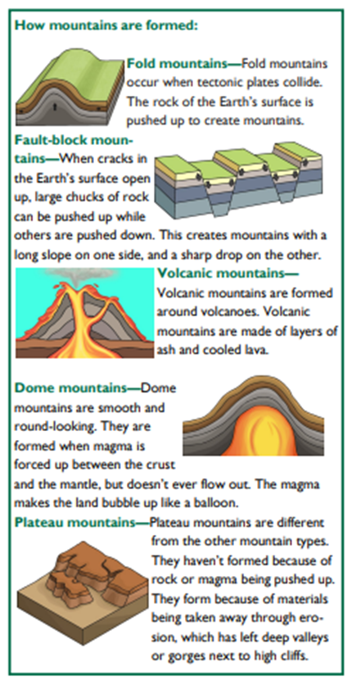
How are mountains formed?

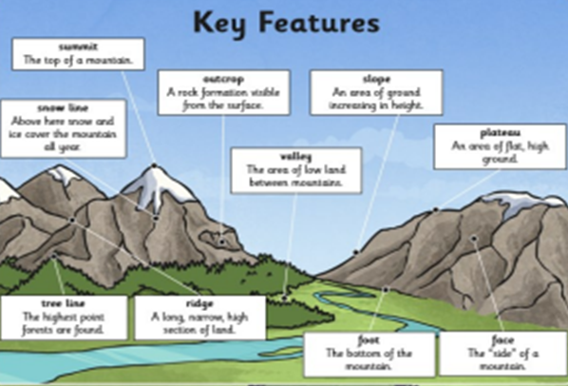
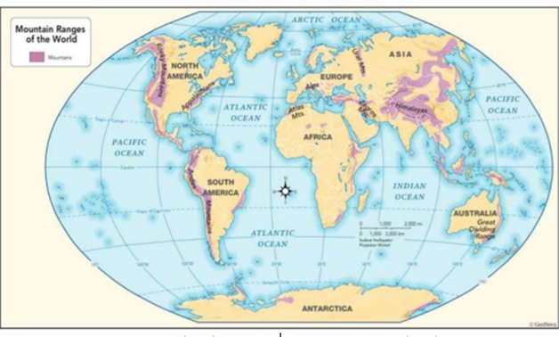
Summit, Andrew Irvine, Range, George Mallory, Altitude, Dome Mountain, Tectonic Plate, Volcanic Mountain, Fold Mountain, Fault Block Mountain

