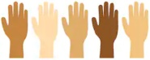
KNOWLEDGE ORGANISER
Y6 PSHE
Overview and Recap  VALUING DIFFERENCE |  |  | Similarities and Differences
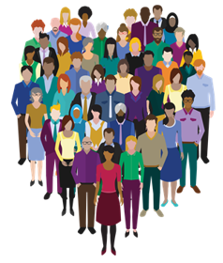  Valuing Difference  We are learning about and celebrating our similarities and differences. We are understanding how to treat other people with fairness and respect.  You should already know that: There are lots of different and interesting people to get to know in the world, and this is a good thing! We should always try to treat everyone with kindness and respect.  - There are many characteristics of strong friendships, which we should work at in order to maintain relationships.  -The things that we read and see in the media about different people and groups is not always true. We should avoid stereotyping people. Gender stereotyping is particularly common.  -Our behaviour can help us to ensure that we are valuing others. It is important to have mutual respect and tolerance for other people – understanding and respecting that some views differ from your own. |  |  | 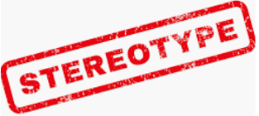  Gender Stereotypes  -A stereotype is an often unfair and untrue belief that many people have about all people or things with a particular characteristic.  -For example, some people may stereotype that girls wear pink, that boys shouldn’t cry, that teenagers are troublesome, or that all gay men act like females. Stereotypes are not based on fact: they are based on assumptions & prejudice (pre-judging people). Therefore, stereotypes can be dangerous.  -Stereotypes about gender are still common. There are beliefs that girls and boys should act in a certain way (for example. ‘boys should be active and play sports like football, and girls should play with dolls’). We should recognise that such stereotypes are not correct, and that both boys and girls are free to explore the things that interest them as an individual.
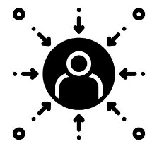
Prejudice
-Prejudice is strongly linked to stereotyping.
"The term prejudice means 'pre-judgment.' A person is prejudiced when s/he has formed an attitude towards a particular group of people before having enough information on which to form a knowledgeable opinion. A negative prejudice is when the attitude is hostile towards members of the group."
-People may hold negative prejudices towards those of other religions, ages, cultures, races, genders or sexualities. Often, different forms of media (e.g. what they see on social media/ TV or what they read in newspapers/ magazines/ websites) can stoke peoples’ negative prejudices.
-It is important to differentiate between what are facts, opinions (or in some cases, what are lies altogether!) It is also important to get to know each person as an individual.
Relationships with Others
Relationships are our connections with other people (or animals).
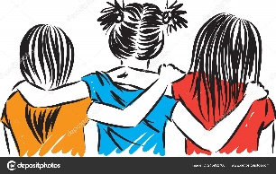
Qualities of Friendships

-A friend is someone that you share a strong bond with. Friends spend time with each other and know each other well.
Qualities of good friendships include:
-Trust -Offering to Help -Sharing -Generosity -Listening -Having a sense of humour/ sharing jokes -Empathy (imagining how each other feels)
-Being Dependable -Celebrating similarities and differences -Encouragement
-Love -Companionship -Help/Advice
-You should be able to think of examples of different ways that you can show these characteristics.
 |  |  | Our Behaviours
 |  |  | 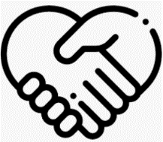  Mutual Respect  Mutual respect is the understanding that we all don’t share the same beliefs and values. It is also about respecting the values, ideas and beliefs of others whilst not imposing our own.  It is the foundation for honesty, trust, and meaningful communication. In order for relationships to remain healthy, both partners must be equally respected and appreciated. Mutual respect is all about showing a proper regard for the dignity of a person or position. |  |  |   Tolerance  -Being tolerant means to “show willingness to allow the existence of opinions or behaviour that one does not necessarily agree with.”  -It is important that we show tolerance for people with ideas, beliefs, and ways of life that differ from our own.  Not only does tolerance help our society live together peacefully, but it can also make us stronger: Having tolerance means that we promote individuality and diversity, which can help to further the human race. People who have thought differently throughout human history have helped to make many changes that have made our lives better.
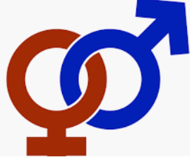
Gender
Gender is a complex topic! We often see inappropriate and outdated ideas about gender in the world around us (see top right). It is important to understand the key terms below.
Biological sex: the gender that someone is born with. Female - XX chromosomes, has a vagina and ovaries. Male - XY chromosomes, has a penis and testes.
Gender identity: how a person feels about themselves in their head ( if they feel they are a boy or girl).
Gender expression: how a person shows their gender by the way they act, behave, dress etc.
Sexual orientation: who someone is attracted to, physically and emotionally attracted, e.g. a person of the opposite sex, a person of the same sex, or both (bisexual).

Self-Esteem
Influence
View
Media
Gender
Stereotype
Racism
Society
Diverse
Mutual Respect
Key Vocabulary

