

UKS2 D.T: TEXTILES
KNOWLEDGE ORGANISER
Overview |  |  |  |  | Designing |  | Key Vocabulary  Textiles  Sew/ Stitch  Aesthetics  Functionality  Appliqué  Stitch  Embroidery  Blanket Stitch  Running Stitch  Cross Stitch  Backstitch
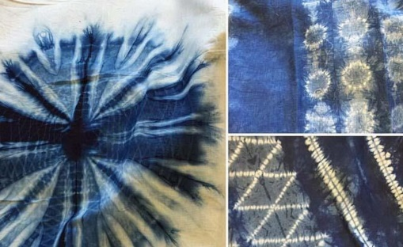  Combining Different Fabric Shapes  Textiles are flexible materials woven from fibres  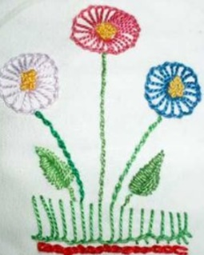  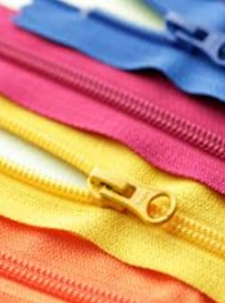  -Textiles are used to make clothing, sheets, towels, linen, carpets, rugs and a wide variety of other products. There are a wide range of textile fabrics.  -Textiles designers and makers can use stitches and other techniques (e.g. embroidery, tie dye) to add to the aesthetic appeal of their product. |  |  |  |  | Designers of textile products need to think about the purpose (what does it do?) and the user (who will use it?)  This project will draw on/ build on the textiles skills you have learnt in prior years.  Fabrics -Different fabrics have different properties (characteristics) which make them good for different purposes. For example, some materials are good insulators (keep things warm/cool, e.g. wool/fleece), others are waterproof/resistant (e.g. laminated fabrics, PUL, TPU, leather), whilst others are eco-friendly (e.g. organic cotton, linen). Consider will help you to meet the purpose and audience of your product.  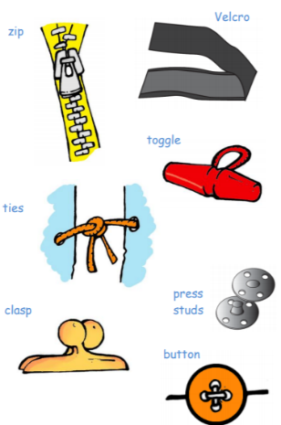  Joining – In addition to the stitches that you have previously learnt, you should plan to use a range of further stitches (see below) can be used to sew and shape curved edges, and to decorate your product.  Decorations – There are a range of decorations that can be added to your design, including buttons, sequins and pipe cleaners. Some will need to be sewn and others can be glued.
Example Textiles
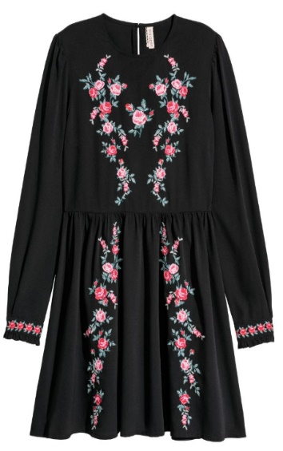 | Clothes  Can be made with cotton/ polyester  Embroidered using a number of different stitching techniques. |  | -A wide range of clothes, including those found in high-end fashion chains, contain embroidery patterns, pictures and designs. Floral patterns (patterns including flowers) are particularly popular.  -Many clothes, for example the dress on the left, are made of polyester. It is very resilient and can stand a good deal of wear and tear. It also holds colour well.  -A number of advanced stitching techniques are often used, including stem stitches for outlines (particularly effective for the individual leaves and stems) and satin stitches for filling in shapes (e.g. the flowers).
 |  |  |  |  | Making & Evaluating
 |  |  |  |  | Making  -You should use a wider range of stitches and decorations.  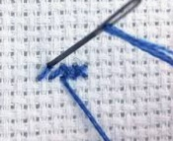  Cross Stitch – A popular form of embroidery stitching in which two diagonal lines are stitched to create an ‘X’ shape. This form of stitching can be easily used to create patterns and pictures.  Running stitch – The stitch goes up and down, through the fabric creating a train of stitches.  Blanket stitch - Blanket stitch is an advanced stitch which uses and up and down and over technique. | Evaluating  -How does your textile look? Would your user like it? Why or why not? How could you improve the way it looks?  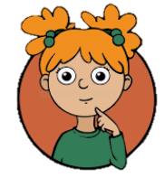  -Are your attached fabrics secure? How did you achieve this? Which type of stitch did you use? How could fabrics be joined more securely?  -Which materials did you choose? What fasteners did you use? Why? Does your product perform its purpose well? Why or why not?  What do you like about your product? How could you improve your product?
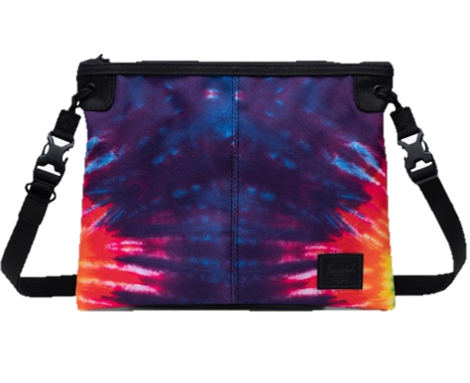 | Bags/ Satchels  Made from synthetic fabrics, with leather strap  Decorated using tie dye  Zip fastener |  | -Bags and satchels can be made from a variety of materials. It is important that the materials are strong enough to bear the weight of the bag’s contents. Leather, cotton and polyester are all often used.  -The tie dye technique has been used to create the vivid colours on this bag, whilst a zip has been joined to the top of the bag as a fastener. This helps to keep the contents safe and secure in the bag, but allows the user easy access when needed.

-When you are not using your needle, keep it in the same safe place.
-When using a needle, keep your fingers well clear. Use a thimble where available.
Make sure that you are wearing the correct equipment for tasks.
If using a sewing machine, follow staff instructions carefully.
If you need to move around with scissors, hold around the closed blades, facing down.
-Walk safely and calmly around the classroom/ workshop.
Report any accidents & clean up properly after yourself.
-Remove any jewellery and tie back long hair.
Health and Safety

