Why should we study the Mayans?

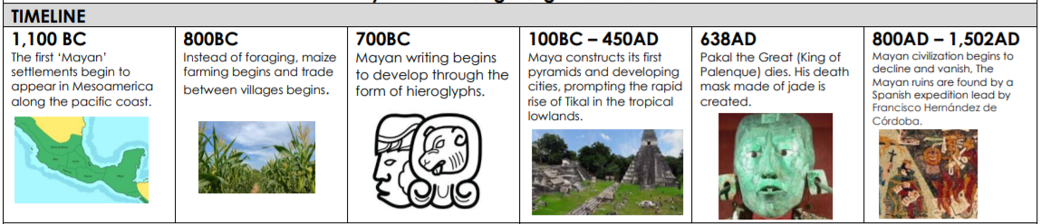

Vocabulary | Definition
Maya | The collective noun for the Mayan people.
Mesoamerica | The region in which the Maya lived, spanning over Mexico and parts of Southern America.
Pyramid | A man-made 3D structure that is built through large cuboids of rock piled upon one another to form a triangular shape.
Chichen Itza | One of the best-preserved examples of a Mayan city.
Hieroglyph | A symbol that has a worded meaning – like our letters.
Maize | Also known as corn – a major resource of food for Mayan people. Part of their religious culture too.
Pok-a-Tok | The Maya’s version of football where players would use their bodies to hit the ball to each other. The losing team would often be sacrificed!
Artefact | A man-made object of historical interest. Many of these were found in ancient Maya sites.

