KEEPING SAFE cybersafety
Y6 PSHE
KNOWLEDGE ORGANISER
Overview and Recap |  |  | Wellbeing
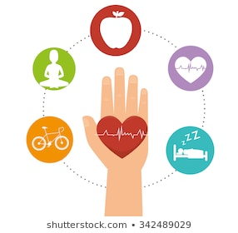  Keeping Myself Safe  We are learning about how to live healthy and safe lives, to promote our wellbeing and to have positive relationships with others.  You should already know that: Being healthy is about feeling good in your body and wellbeing is about feeling good in your mind. Our relationships with other people are important for our health, wellbeing and happiness.  Habits are repeated behaviours, which can be positive or negative. When a person loses control of a habit, they can become an addiction. Many things can be addictive, including some drugs and alcohol.  -All people have emotional needs that we would like to be met. Recognising these helps us to become confident and secure individuals. We should also learn to become independent and responsible.  -We should think carefully before we post anything online. Any information that we share can spread rapidly. The traffic lights system is a good way of maintaining online safety. |  |  | Emotional Needs  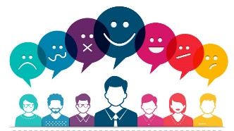  We all have emotional needs that need to be met in order for us to feel safe, healthy and happy.  Some examples of our emotional needs are:  By recognising that we have basic human emotional needs and the ways we can get those needs met can help us to be more confident and secure individuals.  - I need to feel that I am good at some things  - I need to have friends  - I need to feel part of a group  - I need to try new things  - I need to have some choice over what I do  - I need to give and receive attention  - I need some time on my own  - I need to feel safe and secure  We should be aware that life is full of ups and downs, good times and times of challenge and hardship.  At times when we do not feel that our emotional needs are being met, we should speak to a trusted adult. |  |  |  | Independence and Responsibility    Independence is about being able to do things for yourself. For example, you can show independence when you complete your homework without being asked to!  Responsibility is about being dependable, making good choices, and being accountable for your actions. For example, you may be given the responsibility of being a prefect for younger children in your school.  Part of becoming an adult is about gaining more independence and taking on more responsibility. It helps to keep ourselves and others safe.
Responsible and respectful
Showing respect to others is vital to developing strong, succeful relationships. Showing others respect and being a role model can encourage pther people to behave repsonsibly. It is qually a important to show someone respect online as it is in person.

Face to face insults, bullying and embarassing is completely unacceptable and equally unacceptable online. In order to protect yourself online and maintain respectful relationships, you should;
-Use nicknames where possible -Only share gaming names with your closest friends
-Never share any perosnal information online, e.g. full names, phone numbers, home address or school that you attend. -Use passowrds where possible to protect yourself and never share these passwords with anyone but your trusted adults.
 |  |  | Staying Safe Online
 |  |  | 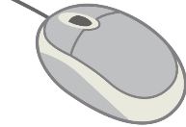  Think Before You Click  -Remember that information can spread rapidly on the internet.  -Even posts, messages or photographs that have been sent privately can be captured and spread by others around the internet. Here, the whole world may see it.  -It can be extremely difficult to remove something once it has been posted. Things that you post now could even resurface many years later – something that may seem funny at the time may not do so later on.  -We should always think about our own safety and should never post anything that may hurt or embarrass someone else. |  |  |   Traffic Lights  When online, we should use the traffic lights system to maintain safety - 'STOP', 'THINK', 'GO'  STOP: when faced with a situation where we are being asked for personal information  THINK: is it ok to share this information? What information is being asked? Who is asking for it? Have I checked with an adult?  GO: I have checked with an adult, I know what information is safe to share
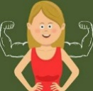  Being Assertive  Sometimes, people want us to do things that we are not comfortable with.  Being assertive is about speaking up for ourselves in a way that is confident and honest about how we feel.  Being assertive is a healthy way of communicating, but does not come naturally to everyone. Some people are passive: they try to avoid confrontations and do not speak up for themselves. Others may be too aggressive, communicating too forcefully.  To Be Assertive  -Stand firm, speak clearly, be friendly & polite, stay calm & confident, negotiate, relax, give eye contact. |   Playing Online  Playing games online can be fun, but it is important to play safely:  -Have specific times in the day for gaming, so that it doesn’t take over life!  -Turn it off at night, so that you can sleep.  -Use passcodes on phones and other devices so that others can’t access accounts or their personal information.  -Remember that it is far safer to only chat to people you know in real life.  -If anything online upsets or annoys you, speak with a trusted adult.

Illegal
Private
Image
Personal
Positive
Misperception
Decision
Physical
Need
Negative
Influence
Key Vocabulary
Emotional

