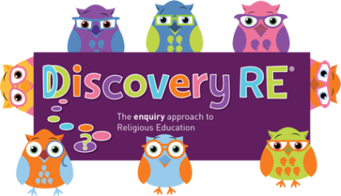


Discovery RE Knowledge Organiser
This knowledge organiser is a guide, offering key information to point the teacher in the right direction as to the beliefs underpinning the particular enquiry.
The summaries must not be taken as the beliefs of ALL members of the particular religion.
Religion /Worldview: Islam | Enquiry Question: What is the best way for a Muslim to show commitment to God? | Age: 10/11 Year Group: 6 Autumn 1
In this enquiry, the children look at the importance of the five pillars to most Muslims. They learn the beliefs behind the practices and understand how Muslims show commitment each day, highlighting the importance of Allah to Muslims.

Core Knowledge (see also background information documents) |  | Link to other aspects of belief | Personal connection / resonance
This enquiry considers the 5 pillars which are central to Muslim life and Worship.  The five pillars are  - The Shahadah is a statement which is repeated many times a day ‘There is one God, Allah, and Muhammad is his prophet’  - Salat - prayer, 5 times a day  - Zakat - Giving 2.5% annual savings to charity  - Fasting – sawm. This commemorates the giving of the Quran to Muhammad  by Angel Gabriel. The fast lasts a month and is during daylight hours  5. Hajj – Pilgrimage to Makkah in Saudi Arabia once in a lifetime |  | - Look at the ways Zakat money is used  - International Muslim charities  - Sunni and Shia different practices  - The Qur’an – some key verses and interpretations | - What 5 things are the most important in my life?  - How do I show commitment at home? At school? To my friends?  - Why is it important to put effort into important things?
Key Terms and definitions | History/Context | Impact on believer/daily life | Spiral curriculum link
Ramadan: Month of fasting. The month the Qur’an was first revealed to Muhammad  Muhammad: the final prophet of Islam  Qur’an: Holy book. The word of Allah in Arabic | - The Five Pillars are central to Sunni Islam, Shia Muslims have the Ten practices too.  - Muslims believe money is loaned to them by Allah – they must use it wisely – life on earth is a test. | - The Shahadah and Salat form a major focus of every day  - Opportunities should be taken to look after the poor and preparations for Ramadan will see communities support each other especially if the fast falls during the hotter months. | This enquiry looks at the 5 pillars, 2 of which may have been studied in previous enquiries (Prayer and the Hajj pilgrimage Yr2 Spring 1 and Summer 2 if studied). These will need referral to as part of the learning.
Home learning ideas/questions:
What are we committed to as a family? How can we support each other? Why is being committed to something not always easy?
© 2020 Discovery RE Ltd

