

Y6 PSHE
KNOWLEDGE ORGANISER
Overview and Recap
Emotional health & wellbeing
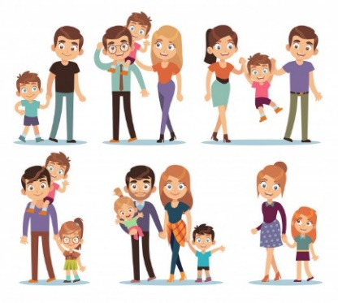  Me and My Relationships  We are learning about ourselves (‘Me’) and how we get along with other people (Relationships).  You should already know that: We are all unique and this is something to celebrate! We should always act appropriately towards others.  -There are special people in our lives, who can help us feel happy and safe. We have a responsibility to be kind and respectful to the special people in our lives. We should know the features of healthy relationships.  -We have many different emotions. We can affect the emotions of ourselves and others through our thoughts, words and actions. Different people may feel differently about the same thing.  -People who love each other may choose to spend their lives together. Some ways of doing this include marriage, living together, or civil partnerships. There should be mutual consent in these arrangements. |  |  | Our Emotional Needs  -Emotions are the way that your mind and body react to the world around you.  -Emotions help to make us human. Emotions formed through evolution, to help us to survive.  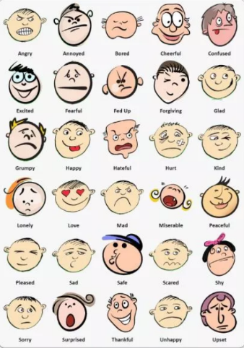  -We all have emotional needs:  -Having caring people around us;  -Having self-esteem (feeling we are good at some things);  -Feeling as though we are a part of a group;  -Trying new things;  -Having some freedom (choice over the things we do);  -Giving and receiving attention;  -Having some time on our own;  -Feeling safe and secure.  When our emotional needs are not being met, or we do not find a situation easy, we can use coping strategies to help us deal with the situation in a positive way. e.g. speaking to someone about how we feel.  Our actions have consequences. We can react negatively or positively. How we react will determine the outcome of the event or the reaction of others.
Healthy Relationships
Relationships are our connections with other living things (especially other people).
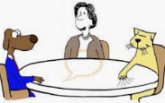  Negotiation and Compromise  Two strategies that can be used to maintain good relationships are negotiation and compromise. Negotiation: Discussion aimed at reaching an agreement.’ Compromise: reaching agreement by people giving up something that was wanted. These involve skills such as listening, turn-taking, communication and selflessness. | 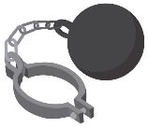  Forced Marriages  -People should always have a choice in who they marry. It is against the law for someone to be forced to marry. People may force others to marry because:  -They think it is a part of their religion or culture;  -They think it is important for reputation/ honour;  -Financial or material gain;  -They feel pressured by their community.
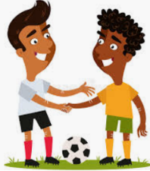
Treating others with Respect

We should try to treat everyone else with respect. We should recognise that other people may have different beliefs, ways of life, cultures and religions to ourselves.

Appropriate, Inappropriate or Illegal
-We should recognise that some actions are appropriate, some are inappropriate, and some are illegal.
-E.g., it is appropriate to shake hands with someone that you are meeting for the first time. It would normally be inappropriate for you to hug a stranger. It is illegal to touch someone who does not want to be touched.
  Long-Term Relationships  -Often, when people love each other, they want to spend the rest of their lives together. Some people choose to get married (sometimes this is for religious reasons). People may also choose to live together or have a civil partnership. These relationships can be same-sex or opposite-sex. People must be 16 (with parent consent) or 18 (without consent) to marry. In some cultures, arranged marriages are customary. |   Unhealthy Relationships  -Unhealthy relationships are relationships that are not good for one/ more than one person involved. They can be difficult to spot.  -In some relationships, one person may pressure another or hold power over them. They may also involve physical, sexual or emotional abuse.  -If you feel that you are in an unhealthy relationship, you should speak to a trusted adult.

Illegal Appropriate
Active
Bystander
Compromise
Key Vocabulary
Collaborate
Negotiate
Trust
Inappropriate
Influence
Passive

