Y5 PSHE

Drug, Alcohol and Tobacco Awareness
KNOWLEDGE ORGANISER
Health |  |  | Wellbeing, Medicines and Health
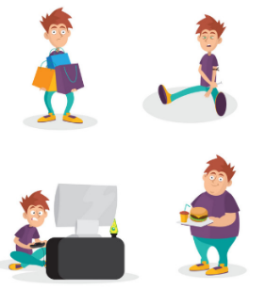  Habit  -A habit is a pattern of behaviour that is repeated – it is often done routinely.  -Some habits are a good thing, e.g. brushing our teeth every morning and evening.  -However, there are some habits that can be bad for our health and wellbeing, e.g. eating too many fatty foods or spending too much time on video games.  -An addiction is a habit that someone finds exceptionally difficult to stop.  -Addictions are not normally good for our health and/ or wellbeing. We can become addicted to many things, but some products contain addictive substances (e.g. nicotine in cigarettes). Once a person has a certain amount of nicotine, they crave more nicotine. This makes it very difficult to stop smoking. |  |  | 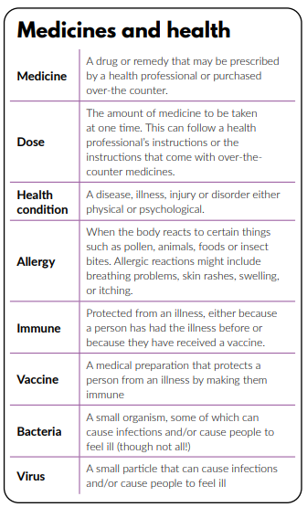
Health
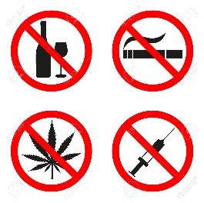
Cigarettes and Drugs Facts

-These days, fewer and fewer young people are smoking. Only 2% of young people aged between 11 and 15 are smokers. This used to be around 10% in 2001.
-The main reasons are because people are more aware of the risks, they would like to stay healthy, they don’t think it is cool and laws have become tougher.
-Many smokers state that they began smoking to fit in with friends when they were younger. It is now illegal to sell cigarettes and alcohol to anyone aged under 18. Shops can be fined for doing so.
- A drug is a substance people take to change the way they think, feel or behave. Many drugs are helpful when used properly (e.g. to treat a medical condition) but can also be harmful when misused.
-Many drugs need a doctor’s prescription, but others can be bought freely from
shops and pharmacies.

 |  |  | Relationships and Staying Safe
Managing Dilemmas
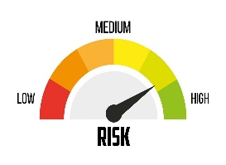
Risk – an action which is taken in a hazardous situation e.g. taking a difficult route on a BMX trail or taking the lead role in a school play.
Dilemma – when we need to make a difficult choice.

Often, when we have a dilemma, it is important to weigh up the risks. We should be able to determine actions that are high risk, medium risk or low risk. To manage the risk, we should consider:
- What is the situation? 2. What is the risk level?
3. How can I make the situation safer? 4. Which choice is the safest? 5. What is the risk level now?

Embarrassment
Dilemma
Decision
Drug
Dare
Risk
Choice
Norm
Cigarettes
Alcohol
Key Vocabulary
Influence

