Word | Definition
 | A substance that provides immunity against a disease
 | A microscopic organism such as a virus
 | A disease that caused millions of deaths and lasted for over 3000 years
 | Micro-organisms that can cause disease
 | An infection spread to humans by fleas that live on rodents
 | Way of preventing disease especially through cleanliness
 | An illness caused by the coronavirus which became pandemic in 2020
 | A British scientist who created the world’s first vaccine
 | A substance that prevents the growth of disease-causing micro-organisms
 | The average period that a person might expect to live
hygiene, COVID 19, vaccine, micro-organism, bacteria, antiseptic, Edward Jenner, life expectancy, bubonic plague, small pox
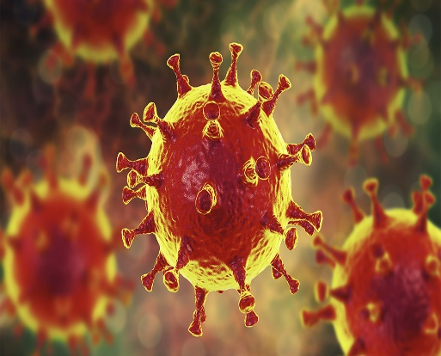
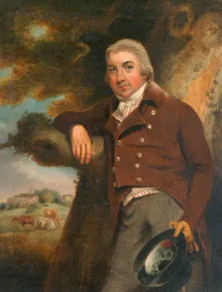
The coronavirus magnified by a microscope
Edward Jenner – the pioneer of vaccines.
How have the medical breakthroughs of the last two hundred and fifty years affected the lives of people in Britain?

