

Emotional Health & wellbeing
Y5 PSHE
KNOWLEDGE ORGANISER
Key question |  |  | Feelings and Emotions
How can I maintain healthy relationships and understand my own and others behaviour? |  |  | Our Emotional Needs  -Emotions are the way that your mind and body react to the world around you.  -Emotions help to make us human. Emotions formed through evolution, to help us to survive.  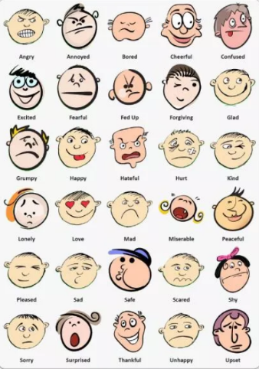 |  |  | Anger  What is anger?  Anger is a emotion.  It is a signal that we think we are being treated unfairly.  Feelings are neither right nor wrong. It is okay to feel angry! We just need to know how to control our anger.  - Recognise anger  - Practice positive responses  - Use the energy to create positive reactions
Healthy Relationships
Relationships are our connections with other living things (especially other people).
Give and Take  -Friends have a responsibility to be respectful and kind to one another.  -Sometimes, friends do not agree with one another. When this happens, two strategies that they can use are negotiation and compromise.  -Negotiation: Discussion aimed at reaching an agreement.’  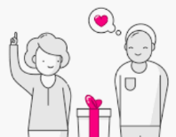  Compromise: reaching agreement by people giving up something that was wanted. | Qualities of Friendship  High-quality friendships should help to make us feel happy and content. There are many different things that help us to make and keep good friendships. They include:  -Valuing each other’s similarities and differences;  -Helping each other to meet their emotional needs  Using negotiation and compromise; -Showing sensitivity and empathy towards one another    -Making sure that the relationship stays healthy
 |  |  | Trust
What do you already know about trust? _____________________________________________________________________________________________
_____________________________________________________________________________________________
_____________________________________________________________________________________________
_____________________________________________________________________________________________

What else do you now know?
_____________________________________________________________________________________________
_____________________________________________________________________________________________
_____________________________________________________________________________________________
_____________________________________________________________________________________________

Connect Collaborate Peaceful problem solving
Self-esteem
Achievement
Success
Assertive
Pressure
Influence
Security
Safety
Key Vocabulary
Emotional Needs

