

KNOWLEDGE ORGANISER
ANCIENT GREECE
Diagram – Map of Ancient Greece |  | Key Vocabulary
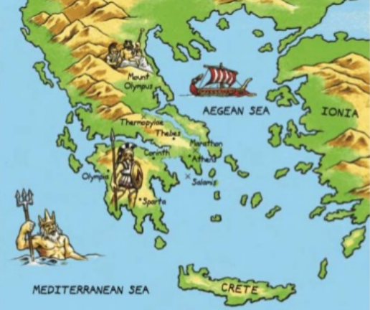  Map of Ancient Greece  Greece’s position next to the sea (there are over 1400 islands) meant Ancient Greeks were a seafaring people. Trade between the islands led to the creation of ‘city-states’ (polis). Each city-state was ruled by a powerful city, led by a ruler or (later) government. Greece is a warm country, but winds from the Mediterranean, and rains from the north, kept temperatures livable and created fertile farming conditions. |  | Evaluate | Form an idea about the value of something
 |  | Review | Look at the good and bad parts of something
 |  | Justify | Show reasons why you are right
 |  | Perspective | A way of looking at something
 |  | Authenticity | Proof that something is real or genuine
 |  | Ancient | Belonging to the very distant past
 |  | Democracy | A system of government which has elected members
 |  | Civilisation | An advanced and fair way of living
 |  | Athenian | A person from Athens
 |  | Spartan | A person from Sparta

