
RE Knowledge Organiser
Religion: Judaism | Enquiry Question: How important is it for Jewish people to do what God asks them to do? | Spring 1

Core Knowledge
This enquiry focusses on food rules and the stories behind the establishment of Kashrut. This is the Jewish code concerning the suitability of food. Food permitted to eat is Kosher (meaning ‘fit’ or ‘proper’).  The Seder Meal  The Passover festival commemorates the escape from slavery in Egypt. A Seder ritual is held on the first two evenings of Pesach in the home. The family sits around the table where in the middle is the Seder plate which is divided up into sections each holding a different type of food representing part of the Exodus story.  The parts include  - A roasted lamb bone with most of the meat removed.  - A hard-boiled egg  - Grated horseradish  - "Charoset" - a paste made of apples, pears, nuts and wine  - A vegetable, such as an onion or potato  - Bitter herbs  - Matzah (unleavened bread) Wine and Saltwater also play a part | 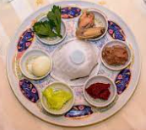  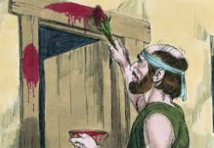  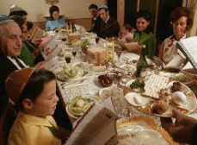
Key vocabulary
Kashrut: food laws
Kosher: food that is fit for Jews to eat
Seder meal: meal commemorating the events of Pesach (Passover)
Synagogue: Jewish place of community worship
Rabbi: Jewish teacher – one respected in the community who leads the worship
10 Commandments: Rules set by God, given to Moses.
Covenant- The covenant is a promise that God made with Abraham
Passover - Passover, or Pesach in Hebrew, is one of the Jewish religion's most sacred and widely observed holidays. In Judaism, Passover commemorates the story of the Israelites' departure from ancient Egypt

