
RE Knowledge Organiser
Religion /Worldview: Judaism | Enquiry Question: How special is the relationship Jews have with God? | Autumn 1

The Ten Commandments were given to Moses by God – they are named as  - I am the Lord your God.  - You shall have no other gods before Me. You shall not make for yourself an idol.  - You shall not take the name of God in vain.  - Remember and observe the Sabbath and keep it holy.  - Honour your father and mother.  - You shall not murder.  - You shall not commit adultery.  - You shall not steal.  - You shall not bear false witness.  - You shall not covet/desire your neighbour’s wife or house.  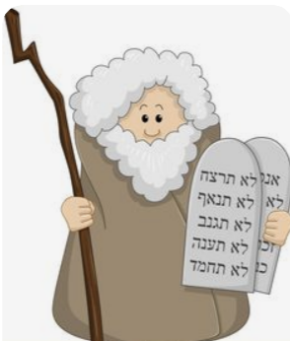 | Vocabulary
 | Synagogue:
 | Rabbi:
 | 10 commandments
 | Torah
 | Abraham

Moses
.

 | Covenant

