
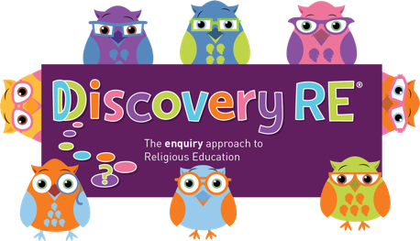
Discovery RE Knowledge Organiser Year 3, ages 7-8
This knowledge organiser is a guide, offering key information to point the teacher in the right direction as to the beliefs underpinning the particular enquiry.
The summaries must not be taken as the beliefs of ALL members of the particular religion.
Religion /Worldview: Christianity | Enquiry Question: Has Christmas lost its true meaning? | Age: 7/8 Year Group: 3 Autumn 2
This enquiry investigates the meaning of Christmas to Christians and examines the elements we see both with the Christmas story in the Bible, and Christmas today

Core Knowledge (see also background information documents) |  | Link to other aspects of belief | Personal connection / resonance
This is the Christian concept of “incarnation”: God becoming man or literally being “made flesh”. Jesus was born in a stable and was visited by a variety of people from very different social classes. There is a significance to the people and places which appear in the Christmas story |  | - Trinity – relationship between God (the Father), Jesus (his son) and the Holy Spirit. The three are “consubstantial”, which means that they exist separately and together as one. | - Do I celebrate Christmas? What do I like about it if I do?  - Can I see a difference between what Christmas might mean to a Christian and what the more commercial messages are?  - What is important to me at this time of year?
Key Terms and definitions | History/Context | Impact on believer/daily life | Spiral curriculum link
Christmas, Christianity, celebrate, Advent, the incarnation, nativity, wise men, Jesus, Mary, Joseph, shepherds | At the time, the shepherds were very lowly, because they had to sleep with the animals as part of their job. | That the shepherds were told shows that God loves poor and lowly people.  The stable as a place of birth shows that Jesus was a lowly and poor person. | Builds on previous Christmas enquiries from Years 1 & 2.
Home learning ideas/questions:
What do we feel about Christmas? How would we feel about important people such as our royalty if they had been born under similar conditions to Jesus? Does it matter that he had such a poor beginning, or do we think that it is what Christians believe now that matters?

© 2020 Discovery RE Ltd

