
Knowledge organiser – Mugurameno Village, Zambia
What will we be learning?
- Locating Zambia on a map.
- Exploring physical and human features.
- Locating the village of Mugurameno.
- Finding out how the river is used in the village.
- Looking at the villagers’ houses.
- Comparing our life with that of the villagers.
Key facts
- Zambia is a country in southern Africa.
- Zambia has a tropical climate, so it’s warm for most of the year. There is a dry season and a wet season.
- There are many national parks in Zambia where the government protects the land and its special wildlife.
- Mugurameno is a village in rural Zambia.
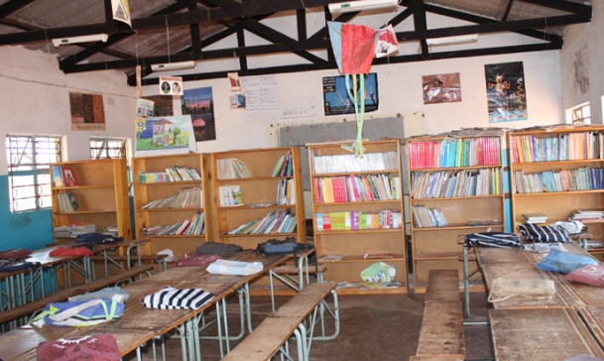
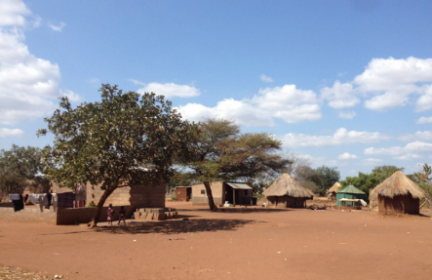
Key knowledge
- Mugurameno village is located right next to the River Zambezi and close to the Lower Zambezi National Park.
- People in Mugurameno use the river for many things: washing, fishing and watering crops. One of the main crops is maize, which is used for making nshima (a sort of porridge).
- People often build their own homes out of bricks made from local clay soil.
- While life is busy for the children of Mugurameno, they go to school and find time to play.

Place names | Geographical terms and processes | Locational terms
Africa  Lusaka  River Zambezi  Southern Africa  Victoria Falls  Zambia | crop  farm  flood  market  waterfall  wildlife | eastern  northern  southern  western
Glossary
crops: plants that are grown to be used or sold (such as rice, corn or fruit)
population: the number of people living in a place
wildlife: the wild animals and plants in an area

