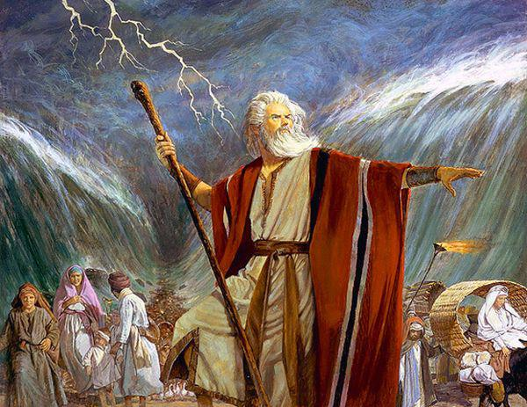
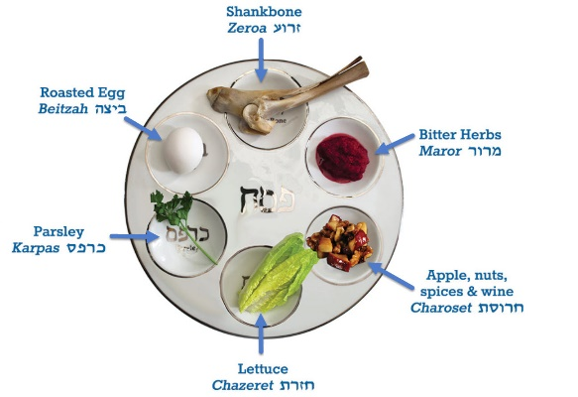

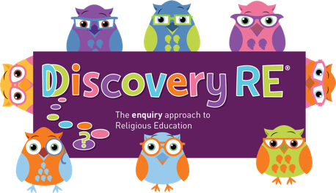
Discovery RE Knowledge Organiser Year 2 Spring 1

Religion: Judaism | How important is it for Jewish people to do what God asks them to do? | Year Group: 2  Spring 1
In this enquiry, the children look at the festival of Passover. They reflect on the stories behind the celebrations and consider the importance of symbols and symbolic actions.

Core Knowledge (see also background information documents) |  | Link to other aspects of belief | Personal connection / resonance
- The story of Passover  - The Jews were captive in Egypt when Moses became their leader, he was inspired to lead the people out of slavery and would lead them to a ‘promised land’.  - A Seder meal – a meal with symbolic foods that remember key parts of the story and the relevant accompanying emotions. |  | - Relationship with God  - Identity as a chosen people  - Symbolism in the synagogue – for example, the careful storage of the scriptures in the Ark  - 10 Commandments which were given to Jesus in the desert after these events. | - Who do I have a special friendship with?  - What do I expect to get from this friendship?  - What do I give to this friendship?  - How does this friendship make me feel?
Key Terms and definitions | Key questions
Covenant: special relationship based on mutual promises  Pesach: festival of Passover  Seder meal: meal commemorating the events of the exodus  Passover | - What is Passover?  - Why is it called that?  - Why did the Israelites and Moses listen to God?  - How do Jews show their commitment to God?  - Who do you listen to and why?  - What is a sedar plate?

