KEEPING MYSELF SAFE & IT’S OK TO TELL
KNOWLEDGE ORGANISER
Y2 PSHE
Overview and Recap |  |  | Wellbeing
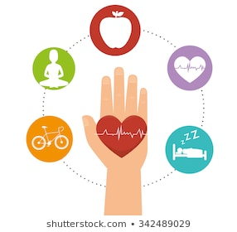  Keeping Myself Safe  Being healthy is about feeling good in your body and wellbeing is about feeling good in your mind.  There are many ways that we can live a healthy lifestyle, e.g. a healthy, varied diet.  When we have a bad feeling about something or feel unsafe, trusted adults can help us.  We should learn the difference between good and bad touches. |  |  | Feeling Safe  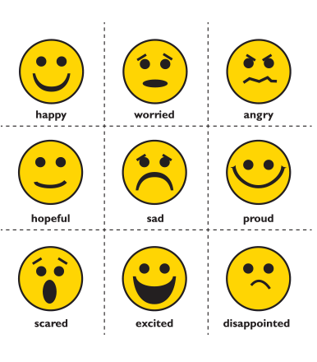  lots of different feelings facial expression body language.  feel anxious, scared, worried or nervous  This often happens when we feel unsafe.  In Kidsafe we call these feelings ‘Yukky feelings’.  There are several things that we can do when we do not feel safe, including removing ourselves from dangerous situations.  Trusted adults can help us. |  |  |  | Knowing How to Respond  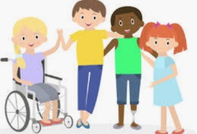  It is important for our mental wellbeing.  You can learn to use the following responses:  Yes – When you feel comfortable about something.  No – When you do not feel comfortable about something  I’ll ask – When you are unsure about something, and want to ask a trusted adult for advice.  I’ll tell – When you know that something is wrong/ dangerous, and so should tell a trusted adult.
Keeping safe
Trust
A trusted adult is someone over the age of 18. They are people that cares about you and want to keep you safe.

Bullying
It is important to know bullying is unacceptable and can happen face to face or online.
Unkind physical or verbal acts that happen Several Times On Purpose can be bullying and we should always say stop to bullying.

You can use your voice assertively to get a bully to STOP.
 |  |  | Relationships
 |  |  | Likes and Dislikes  There are nice ways that we can touch other people and ways that give us Yukky feelings.  It is ok to tell people when a touch is not nice – even family and friends.  Remember to our Kidsafe rules;  Say No Walk away  Tell a trusted adult |  |  | 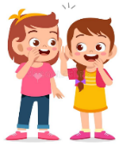  Secrets  A secret is when someone tells us not to tell something.  Secrets can sometimes be bad.  We don’t keep secrets that make us feel uncomfortable or give us Yukky feelings. .  Our bodies tell us when secrets are  Trusted adults can help.
Are ratings
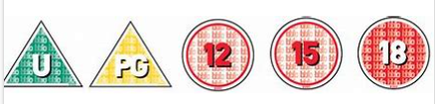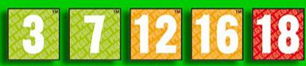

Film age ratings are shown in triangles and circles (1st picture).
Game ratings are shown in squares and use green, amber and red to show if they contain appropriate content (2nd picture).
9pm watershed is there to protect children from seeing inappropriate things that may give them Yukky feelings.

Bullying
Age rating
Argue
Private places
Personal Details
Online Safety
Yukky feelings
Kidsafe
Trust
Unsafe
Safe
Key Vocabulary
Secret

