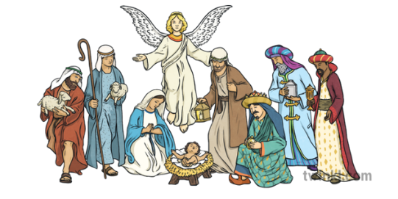



RE Knowledge Organiser Year 2
Enquiry Question: Why do Christians believe Jesus was a gift from God?

Religion /Worldview: Christianity |  | Age: 6/7 Year Group: 2 Autumn 2
This enquiry investigates how Christians believe in Jesus as a gift of love to everyone.

Key Vocabulary | Key Questions | Key Knowledge
Jesus  Bible  Christmas  Incarnation  Christianity  Belief  Advent  Trinity  Faith  Religion  Agape | Why do Christians believe God gave Jesus to the world?  Is God important to everyone?  How could we show love to the world?  How can a person can be or bring a “gift” into my life that is not material?  What would be the impact if everyone showed love to everyone (agape-universal love)? | I can say how I could help solve a problem by showing love.  I can remember the Christmas story and start to explain that Christians believe Jesus was a gift from God.  I can tell you why Christians think God gave Jesus to the world.

