KNOWLEDGE ORGANISER
Y2 PSHE
Overview and Recap  ANTI-BULLYING |  |  | Similarities and Differences
  Valuing Difference  We celebrate similarities and differences.  We treat others with fairness and respect.  Special people in our lives help and support us.  We build strong relationships with acts of kindness.  We are all unique and special!  Our behaviour affects other people.  We should try to include others and solve conflicts. |  |  |   Similarities  Lots of things make us similar to other people.  We are all human.  All live on planet Earth.  We can all think and make choices.  We should do all that we can to be kind to one another. |  |  |   Differences  Lots of things that make us different to other people.  We are all unique and special!  This is a good thing that should be celebrated!  We may be different but we are all equal.
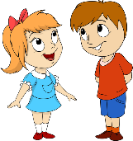
What Makes Us Who We Are?

-Appearance = the way that we look (hair & eye colour, facial features)
-Personality = the features of our character (sense of humour, kindness)
-Interests = the things that we like and don’t like (favourite foods, hobbies)
-Skills/Talents = the things that we are good at (sports, school subjects, music)

You should be able to notice how you are similar and different to your friends/family.
Relationships with Others
Relationships are our connections with other people (or animals).
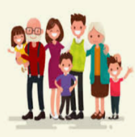
Special People

People who are important in our lives.

They help us or take care of us. We should show them that we care about them and that they are important to us.

Special people can come from lots of different places in our communities.
 |  |  | Our Behaviours
 |  |  | Including Others  It feels good to be part of a team or group. It is not very nice to feel left out.  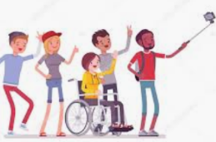  We should always try to find ways to include everyone.  value differences  link with others  Make sure no one is left out! |  |  |   Solving Problems  Sometimes have different points of view.  To solve these problems, we should listen to others.  Active listening techniques: eye contact, nodding head, make positive noises, don’t be distracted.  Listen to everyone’s point of view, work towards a resolution, compromise with one another.
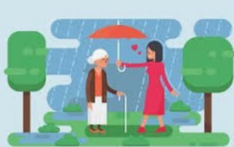
Acts of Kindness

We all have lots of power.
The ways that we speak, and act can have a huge impact on other people.
Kindness is about being friendly, generous and considerate. It shows other people that you care.

Speak Kindly Act Kindly Be Kind!

Upperby Values – Respect, Responsibility, Resilience, Caring, Confidence, Aspiration

Point of View
Respect
Active Listening
Equal
Tolerance
Opinion
Left Out
Include
Key Vocabulary

