
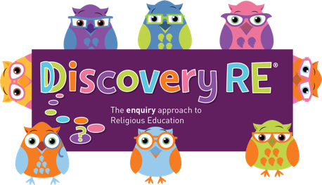Discovery RE Knowledge Organiser Year 2
Religion /Worldview: Christianity | Enquiry Question: How important is it to Christians that Jesus came back to life after his crucifixion | Year Group: 2 Spring 2
This enquiry examines the events of Easter Sunday, Jesus’ resurrection, and the impact this has on Christians today.
Core Knowledge (see also background information documents) | Personal connection
Jesus was put to death on a cross.  Christians remember this event on Good Friday.  Jesus’ body removed from the cross.  After he died, he was put into a tomb with a stone rolled across the doorway.  On Easter Sunday, visitors to the tomb found it empty.  Mary Magdalene saw Jesus in the gardens surrounding the tomb, showing he had risen from the dead.  The disciples wrote about these events (books of the New Testament). | - What do I think about this belief – can I understand why it might be important to Christian?  - Can I imagine how it would feel to be loved by somebody so much that they would do anything to save me?
Key Terms and Definitions | Impact on believer/daily life
Resurrection: rising from the dead  Salvation: the saving of mankind from permanent separation from God by the death and resurrection of Jesus, whom Christians believe is the Son of God.  Disciples: Jesus’ special friends  New Testament: the part of the Bible which follows the birth of Jesus. | Christians believe that God as Jesus, could overcome even death.  Resurrection means that Jesus defeated death for himself and for everybody.  Jesus/God loved Christians enough to be hurt and die for them.
© 2020 Discovery RE Ltd

