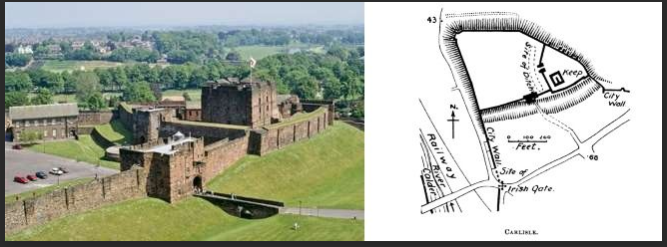
Knowledge Organiser Year 2 - Local History - Carlisle Castle
Key Vocabulary
Castle - a large building, typically of the medieval period, fortified against attack with thick walls, battlements, towers, and in many cases a moat.
Curtain walls - a fortified wall around a medieval castle, typically one linking towers together.
Fortification - a defensive wall or other reinforcement built to strengthen a place against attack.
Garrison - a group of troops stationed in a fortress or town to defend it.
Roman - relating to ancient Rome or its empire or people. A period in history
Motte and Bailey - a castle consisting of a fort on a motte surrounded by a bailey.
Keep - located within a courtyard and surrounded by a curtain wall, was the heart of a medieval castle.
Tower - is one of the defensive structures used in fortifications, such as castles, along with curtain walls.
Monarch - the king or queen who rules over the country.
Ruler - the person exercising government.

72 ROMAN CITY-A large Roman fort is established on the site of the later castle.

1092 -FIRST CASTLE

12TH-15TH CENTURIES BESIEGED The Scots hold the town and castle to siege in 1173, 1174, 1216, 1296, 1297, 1315 and 1461, making it the most frequently besieged place in the British Isles.

1122- THE CASTLE FORTIFIED-Henry I visits Carlisle and orders that the castle be fortified. This may be the origin of the keep.

1308- ADDED COMFORT Queen Mary's Tower is added to provide better accommodation.

16TH CENTURY RENOVATIONS Henry VIII orders a review of Carlisle's defences, resulting in the largest building campaign since the 12th century.

1567 EXPENSIVE ROYAL GUEST-Mary, Queen of Scots, flees to England and is housed in the Warden's Tower, later Queen Mary's Tower, at Elizabeth I's expense.

20TH CENTURY LOST TO HISTORY- Many features are destroyed or altered. A dual carriageway separates castle from city.

