Y2 PSHE
KNOWLEDGE ORGANISER
Overview and Recap  Emotional Health & Well-being |  |  | Feelings and Emotions
Me and My Relationships  We are learning about ourselves and how we get along with other people.  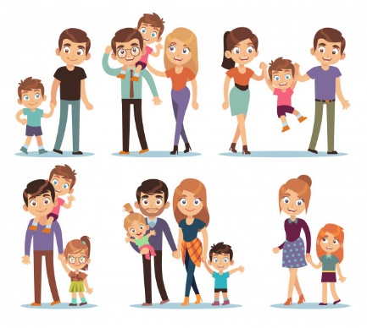  We are all special.  Some things make us like other people.  Some things that make us different to other people.  We have many different feelings. |  |  | Thinking about Feelings  Our feelings are also known as our emotions.  Happy Confused  Scared Angry.  Our emotions can often be seen through our facial expressions and our body language.  It is ok and natural to have any feeling.  We can talk about our feelings to people that we trust. |  |  | 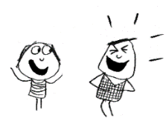  Affecting Feelings  The way that we behave can affect the way that others feel.  If we are kind to someone, we can make them feel happy.  We may even cheer them up if they were feeling sad!  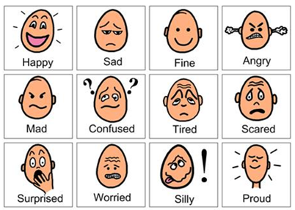
Healthy Relationships
Relationships are our connections with other living things (especially other people).
Understanding other people’s emotions

Compassion Empathy Tolerance

It is important understand others’ feelings. Put yourself in someone else’s shoes!
 |  |  | Being Kind
Acts of Kindness
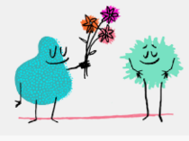
Kindness generosity friendly

‘I like your hair’… ‘You are good at…’

Holding a door open

Helping someone to carry something.


Helping Others

We all feel sad sometimes.
Lots of different reasons why someone may feel sad.
We can help others to feel better.

talk to them help them tell a grown up about their problem
cheer them up by playing with them
Embarrassed
Emotions Kindness Care
Yukky feelings
Friendship Trust
Confused
Respect
Rely
Worried
Key Vocabulary

